Hi! What is Modesty? Well, behavior, manner, or appearance intended to avoid impropriety or indecency is what it means.
Can you find the words BEAUTY, DECENCY, ELEGANT, FREEDOM, MANNERS, PROPER and REFINED in the crossword below?

J E N M L P S Y Y C
O F V F R R C P T C
J J G O E N E L U O
N E P N E J K R A D
D E N C O R G C E E
R A E N J P D Q B N
M D T N A G E L E I
F R E E D O M R D F
P J K K Q U R D A E
G U M B I K P Y Y R


Loving Math the 3/4ths Way!

We say a Queen dresses in 3/4ths clothing. Well, first, let us explore what 3/4ths means mathematically!
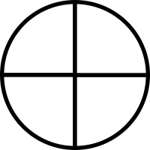
Do you like pie or pizza?? Me too! We can use the CIRCLE to show what 3/4ths looks like!
Yummy, yummy, yummy! Decorate 3 parts of each whole circle. Have fun! Make pie slices or add your favorite Pizza toppings!
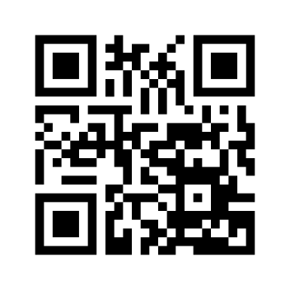

What a Watery World We Live In!
Did you know we live on a planet that is covered by 3/4ths water? That means the 3 parts of the total Earth’s land mass is hidden under water. On us that equates to sleeves just below the elbow, pants/skirts to mid-calf and your head covered. Below color the waters on this map BLUE. (Parents scan the QR code on this page for a free download to the TRUE MAP showing the correct size of Africa.)
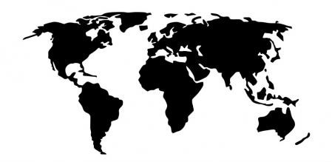
On the next pages become a Fashionista! Draw and color the paper dolls with clothing to show how “Refined and Fly” 3/4ths styles are!

Remember- pretty head wraps, at least mid-calf and to the elbows..
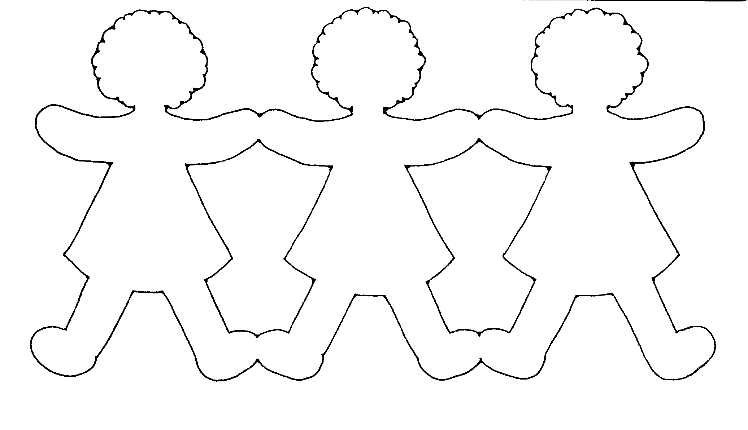

Can you make this Beauty with elegant RED, BLACK and GREEN colors?
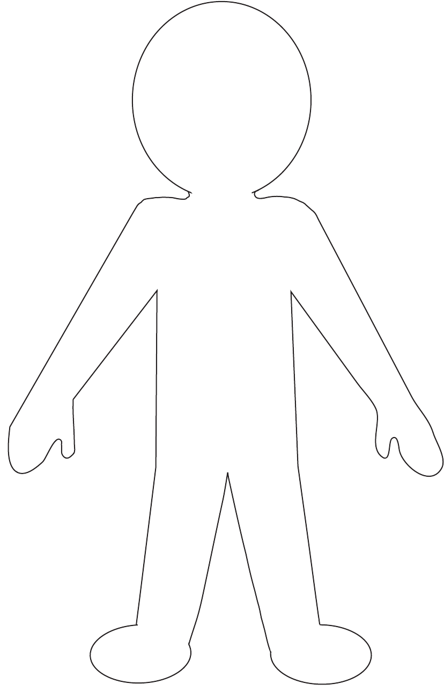
Fun Fact Option: Parents scan this QR CODE to introduce the RBG flag and the meaning of the colors to your child.

